Group Report Team 08

# Introduction (Marc)

This report shows how we in the role of the Business Analyst performed a real Use Case under the prerequisite of the agile project methodology.

Summary of the problem

Approach

Outline

# Elicitation and Collaboration (Ragesh)

As described in Babok Guide Version 3, as first step we conducted the tasks mentioned as part of the Elicitation and Collaboration Knowledge Area. The objective in this stage was to gain information about the as-Is situation. For this purpose, we first arranged a short meeting with project sponsor, Professor Dr. Knut Hinkelman. The goal of this meeting was to understand and discuss the current (as-is) and potential future (to-be) state. Another objective was to obtain information about potential other stakeholders. Those stakeholders were required to gain information, build requirements out of their inputs and finally to confirm those requirements.

Not every task of Elicitation and Collaboration Knowledge Area was considered in our approach. The following section provides an overview about the tasks and goals, the team conducted in this stage.

**Prepare for Elicitation:**

As a first step, the team discussed the potential stakeholders in a brainstorming session. The stakeholders were discussed based on their knowledge areas – modules taught - and importance to understand the as-is situation. The latter was especially important in defining the stakeholder representing the student’s points of view. Then in a second step the main stakeholders were identified and confirmed within the team. In this stage not relevant stakeholders were eliminated as otherwise too many stakeholders could make the elicitation phase more difficult.

Finally, the determined stakeholders were grouped into two stakeholder group (Students and Lecturers).

After that, based on the stakeholder group corresponding questionnaire were created with stakeholder specific questions. Importance was given on the pre-information to ensure that stakeholders understand the goal of this project. The questionnaire was created in Google Forms and sent out via E-Mail to the stakeholder groups. The stakeholders obtained one-week time to complete the questionnaire.

**Conduct Elicitation:**

Once the deadline for the questionnaire has reached. The gained information (key phrases) from the questionnaire were transferred into an excel spreadsheet.

As a second step the team started to evaluate the key words to prioritize the stakeholder needs and identify potential solutions that may meet those needs.

**Confirm Elicitation Results:**

As a next step, we organized a call with Dr. Andreas Martin (Professor at FHNW) to confirm our elicitation results. We guided the call by informing him about the outcome from the questionnaire and requested him to share his opinion to our results.

We also arranged a focus group with four BSc BIS students to confirm our elicitation results. This was done by creating charts based on their feedback introducing those illustration as part of this focus group meeting. We then further discussed their view on our results.

In both settings the main purpose was to catch any missing information and to close those gaps.

**Which stakeholders were involved and why?**

**Domain Subject Matter Expert :**

* Dr. Prof. Knut Hinkelman and Dr. Prof. Holger Wache having the expertise in the situation of our business objectives and giving us guidance about which other sources should be conducted to get information.

**End User:**

* Lecturers teaching BSc BIS sharing their view on the current situation and providing us with potential future needs to be considered in the business objectives.

**Customers:**

* Graduated BSc BIS Students sharing their experience from the studies and how they could connect their knowledge in their working environment.
* Current BSc BIS Students sharing their feelings and experience during their studies.

**How did you obtain information from stakeholders?**

**Document Analysis:**

Documents regarding the BSc BIS studies at FHNW and a MSc Thesis written by Tatevik Brändlin were analyzed to understand the current situation and already performed surveys and observation regarding this topic.

**Interviews:**

Interviews were conducted with current BSc BIS Students and Dr. Martin Andreas (Lecturer at FHNW) to gain more knowledge about their point of view on the current study programme at FHNW.

**Questionnaire:**

Two different questionnaires (targeting the stakeholder group – students and lecturer) were created and shared via e-mail to gather feedback from stakeholders about their satisfaction and point of view on the current study programme at FHNW.

**How did you communicate with stakeholders?**

Communication with the stakeholder were conducted face-to-face (interviews with Students and Domain Subject Matter Experts) over Skype and with the questionnaire.

**Which techniques were applied and what are the experiences?**

During the collaboration and elicitation phase different kind of techniques were conducted to address the stakeholder groups. Primary selection criteria for the techniques was how the stakeholder group can be attained most effectively to get the most powerful inputs out of them.

As a first step within the project team a brainstorming session was conducted to get a big picture about the understanding of the group members on the business objectives. Based on the first output clustering and topic elimination were conducted to keep the scope lean and achievable during the given timeframe.

Furthermore, the team did document analysis regarding the current situation to gain information around analyses and observations already performed on this topic.

From the document analysis the current study program was understood. Afterwards, the team performed a functional decomposition to break down the insights and to understand what topics are taught at which stage.

Finally to understand the as-is situation interviews were performed and a questionnaire were created and shared with student and lecturers to gain knowledge about the current situation and the point of view by the corresponding stakeholder group.

# Requirements Lifecycle Management (Lawrence)

How were changes to requirements evaluated?

If we had any changes to the requirements, we followed the BABOK Requirements Life Cycle Management:

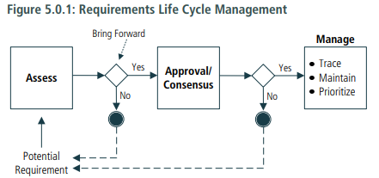

Figure 1: Babok Guidelines p. 76

Any changes made during the stages mentioned in section 5 Requirements Analysis and Design Definition were first assessed and evaluated if the implications of the proposed requirements align not only with our overall strategy but also if it increased the value of the solution as well as identified additional potential risks which we have to consider.

and a consensus within our group were made. According to the BABOK

How did you maintain and trace requirements?

When tracing requirements, business analysts consider the value that each link is supposed to deliver, as well as the nature and use of the specific relationships that are being created. The effort to trace requirements grows significantly when the number of requirements or level of formality increases.

There are several types of relationships that the business analyst considers when defining the traceability approach:

• Derive: relationship between two requirements, used when a requirement is derived from another requirement. This type of relationship is appropriate to link the requirements on different levels of abstraction. For example, a solution requirement derived from a business or a stakeholder requirement

• Depends: relationship between two requirements, used when a requirement depends on another requirement. Types of dependency relationships include: • Necessity: when it only makes sense to implement a particular requirement if a related requirement is also implemented. • Effort: when a requirement is easier to implement if a related requirement is also implemented. • Satisfy: relationship between an implementation element and the requirements it is satisfying. For example, the relationship between a functional requirement and a solution component that is implementing it. • Validate: relationship between a requirement and a test case or other element that can determine whether a solution fulfills the requirement.

Requirements traceability is documented and maintained in accordance with the methods identified by the business analysis approach. Requirements management tools can provide significant benefits when there is a need to trace a large number of requirements that may be deemed unmanageable with manual approaches

• Domain Knowledge: knowledge of and expertise in the business domain needed to support traceability. • Information Management Approach: provides decisions from planning activities concerning the traceability approach. • Legal/Regulatory Information: describes legislative rules or regulations that must be followed. These may need to be considered when defining traceability rules. • Requirements Management Tools/Repository: used to store and manage business analysis information. The tool may be as simple as a text document or as complex as a dedicated requirements management tool.

The requirements were maintained in an excel

Requirements are maintained so that they remain correct and current after an approved change. Business analysts are responsible for conducting maintenance to ensure this level of accuracy is retained. For requirements to be properly maintained they must be clearly named and defined, and easily available to stakeholders. Business analysts also maintain the relationships among requirements, sets of requirements, and associated business analysis information to ensure the context and original intent of the requirement is preserved. Repositories with accepted

taxonomies assist in establishing and maintaining links between maintained requirements, and facilitate requirements and designs traceability. .2 Maintain Attributes While eliciting requirements, business analysts elicit requirement attributes. Information such as the requirement’s source, priority, and complexity aid in managing each requirement throughout the life cycle. Some attributes change as the business analyst uncovers more information and conducts further analysis. An attribute may change even though the requirement does not. .3 Reusing Requirements There are situations in which requirements can be reused. Requirements that are candidates for long-term use by the organization are identified, clearly named, defined, and stored in a manner that makes them easily retrievable by other stakeholders. Depending on the level of abstraction and intended need being addressed, requirements can be reused: • within the current initiative, • within similar initiatives, • within similar departments, and • throughout the entire organization. Requirements at high levels of abstraction may be written with limited reference to specific solutions. Requirements that are represented in a general manner, without direct ties to a particular tool or organizational structure, tend to be more reusable. These requirements are also less subject to revision during a change. As requirements are expressed in more detail, they become more tightly associated with a specific solution or solution option. Specific references to applications or departments limit the reuse of requirements and designs across an organization. Requirements that are intended for reuse reflect the current state of the organization. Stakeholders validate the proposed requirements for reuse before they can be accepted into a change.

Information Management Approach: indicates how requirements will be managed for reuse.

How did you manage the backlog?

The backlog were managed in Trello. In the first two sprints, we had issues constantly updating our Trello. Our group had all the tasks in mind and used the tool as it was seen as a requirement from the course. However, during the coaching at the end of sprint two, we received guidance how to make valuable use of Trello, in order to help us instead of seeing it as a “burden”. We sorted the tasks into different color. Each color belongs to one of our sprints. This made it easier for us to link the output of the tasks to each sprint.

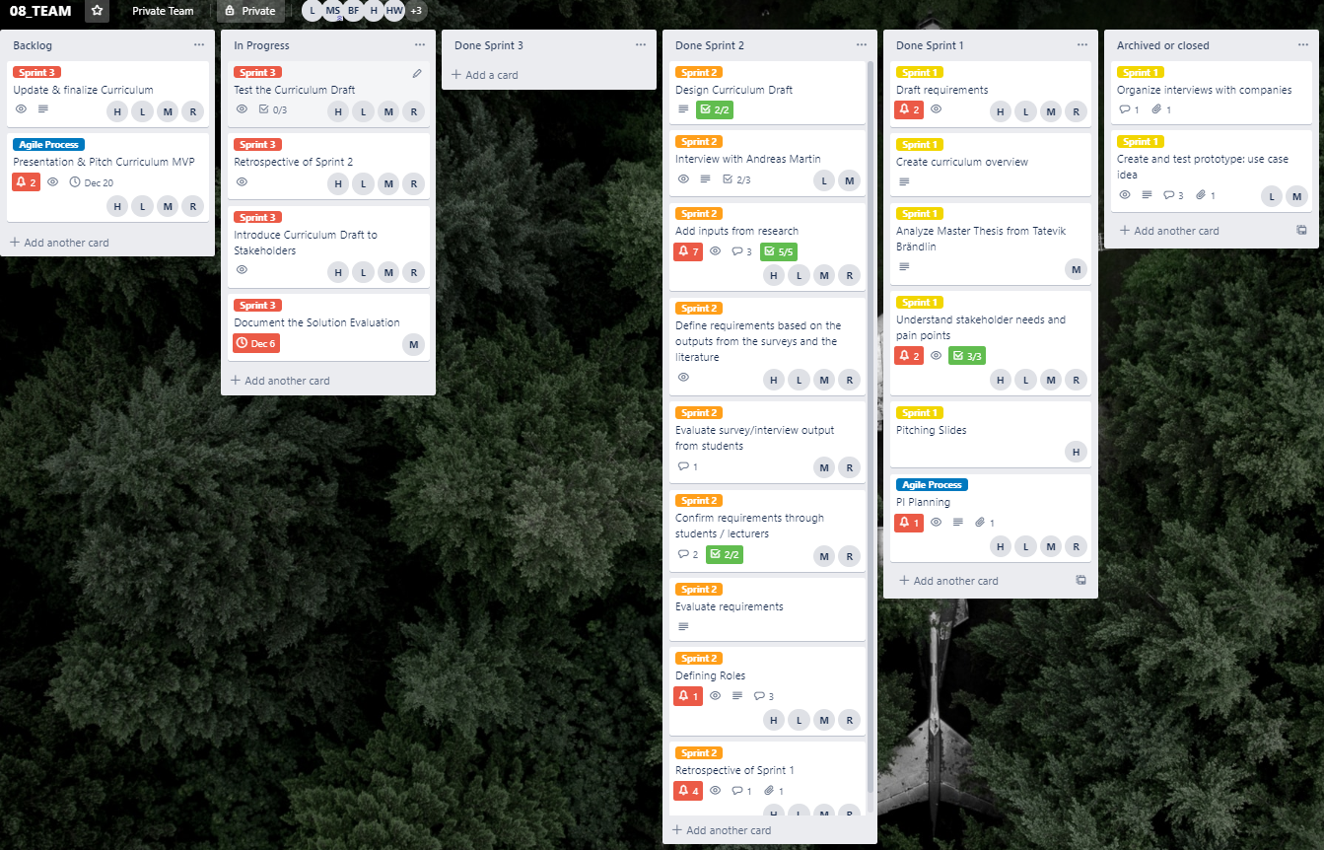

# Strategy Analysis (Haris)

# Requirements Analysis and Design Definition (Haris)

Comment LM:

1. Knut Hinkelmann
2. 2All BSc BIS students & all BSc Programming lecturers
3. Focus group

Important: mention also failure questionnaire with Bradley!

# Solution Evaluation (Marc)

Assessment oft he Solution Evaluation

